Child Protection Policy & Guidance
ECE Services: You may use this policy but you must ensure that you adapt it to your own organisation to ensure that you can honour the commitments it makes. You must consult staff and whānau before adopting any policy. Specifically, you must ensure that all staff understand it.

Policy summary
This policy outlines our commitment to child protection. It includes our protocols when child abuse is reported to us or suspected by us. It also includes practice notes on measures to be taken to prevent child abuse. Staff are expected to be familiar with this policy and to abide by it.

Purpose statement
We have an obligation to ensure the wellbeing of children in our care and are committed to the prevention of child abuse and neglect and to the protection of all children. The safety and wellbeing of the child is our top priority when investigating suspected or alleged abuse.
We support the roles of the New Zealand Police and Oranga Tamariki (formerly Child, Youth and Family) in their investigation of suspected abuse. Our role is to advocate and escalate concerns about a child’s safety, and we will report suspected/alleged abuse to these agencies and to the The Director of Regulation (ERO) (HS128).
We will work to support families/whānau to protect their children, and we will always work to provide a safe environment, free from neglect, physical, emotional, verbal or sexual abuse.

Policy principles
- The interest and protection of the child is paramount in all actions.
- We recognise the rights of family/whānau to participate in the decision-making about their children.
- We have a commitment to ensure that all staff are able to identify the signs and symptoms of potential abuse and neglect and are able to respond appropriately.
- We are committed to supporting all staff to work in accordance with this policy, to work with partner agencies and organisations to ensure our approach to child protection is consistent and high quality.
- We will always comply with relevant legislative responsibilities.
- We are committed to share information in a timely way and to discuss any concerns about an individual child with colleagues or the Person in Charge.
- We are committed to promote a culture where staff feel confident that they can constructively challenge poor practice or raise issues of concern without fear of reprisal.
- This policy will be reviewed at least every three years or following an incident.

Identifying possible abuse or neglect (HS125)
Child Abuse is defined in the Aotearoa’s Oranga Tamariki Act (1989) as “the harming (whether physically, emotionally, or sexually), ill-treatment, abuse, neglect or deprivation of any child . . . .”

Emotional Abuse
Emotional abuse occurs when a child’s emotional, psychological, or social well-being and sense of worth is continually battered. This includes confinement, isolation, verbal assault, humiliation, intimidation, infantilisation, or any other treatment that may diminish the sense of identity, dignity, and self-worth. We also include exposure to Family Violence in this category.

Neglect
Neglect is a pattern of behaviour that occurs over a period of time and results in impaired functioning/development of a child or young person. It is the failure to provide for a child’s basic needs. Neglect may include the following.
Physical – failure to provide basic needs of food, shelter or warmth
Medical – failure to seek, obtain or follow through with medical care for a child or young person
Abandonment – leaving a child or young person in any situation without arranging necessary care and with no intention of returning
Neglectful supervision – failure to provide developmentally appropriate or legally required supervision
Refusal to assume parental responsibility – unwillingness or inability to provide appropriate care for a child or young person

Physical Abuse
Physical abuse can be caused from smacking, punching, beating, kicking, shaking, biting, burning, or throwing the child. Physical abuse may also result from excessive or inappropriate discipline or violence within the family and is considered abuse regardless of whether it was intended to hurt the child. Physical abuse may be the result of a single episode or a series of episodes.

Sexual Abuse
Sexual abuse includes acts or behaviours where an adult, older, or more powerful person uses a child for a sexual purpose. There are 2 different types of child sexual abuse. These are called contact abuse and non-contact abuse.
Contact sexual abuse involves touching activities where an abuser makes physical contact with a child, including penetration. It includes sexual touching of any part of the body whether the child is wearing clothes or not; rape or penetration by putting an object or body part inside a child's mouth, vagina or anus; forcing or encouraging a child to take part in sexual activity; making a child take their clothes off, touch someone else's genitals or masturbate.
Non-contact sexual abuse involves non-touching activities, such as grooming, exploitation, persuading children to perform sexual acts over the internet and flashing. It includes encouraging a child to watch or hear sexual acts; not taking proper measures to prevent a child being exposed to sexual activities by others; meeting a child following sexual grooming with the intent of abusing them; online abuse including making, viewing or distributing child abuse images; allowing someone else to make, view or distribute child abuse images; showing pornography to a child; child exploitation.
Staff should become familiar with the possible physical and behaviour clues to child abuse listed on pages 12 and 13. Additional details of ‘Signs and symptoms’ can be found on page 16 of this document along with a list of further training resources on page 11.

Responding to/reporting suspected abuse or neglect
Staff members will discuss suspicions with a senior staff member.
All suspicions, observed incidents or reports of incidents should be reported directly to the Person Responsible as soon as possible, who will immediately take steps to protect the child(ren) and record the report. Follow the steps in the flowchart on page 14.
An incident record template is provided on page 17 of this document.
The process for responding to child abuse is given in the ‘Reporting Process Flowchart’ on page 14 of this document.

Ask yourself these questions
- Is the child's behaviour a sign of abuse or neglect, or are there other things going on in the family that could affect them?
- How is the child's behaviour?
- How is the child's development?
- Has the child or family hinted at, or said that something is wrong?
- Are there signs of family violence?
- Do I sense the family is struggling, or the child is at risk in some way?
If there is clear evidence or reasonable cause to believe an instance of child abuse has taken place, the Person Responsible shall notify Oranga Tamariki: 0508 326 459. Where evidence is less clear but there is cause for suspicion of abuse, the Person Responsible shall consult Oranga Tamariki ADASSIST: Phone 0508 EDASSIST (0508 332 774); Email: edassist@ot.govt.nz.
It is essential to maintain a confidential record, including observations of the child’s behaviour, continually for some months following an allegation or incident.
In addition to guiding staff to make referrals of suspected child abuse and neglect to the statutory agencies (i.e. Oranga Tamariki or the Police), this child protection policy will also help staff to identify and respond to the needs of the many vulnerable children whose wellbeing is of concern. Throughout New Zealand statutory and non-statutory agencies provide a network of mutually supportive services, and it is important for our organisation to know about and work with these agencies to respond to the needs of vulnerable children and families/whānau in a manner proportionate to the level of need and risk (C113).

A teacher’s ‘in the moment’ response to suspicion of child abuse

This response is designed as an ‘in the moment guide’ to support teachers who come face-to-face with a disclosure or have a suspicion arising from their interaction with children. Staff must comply with the detail of the reporting process outlined in their child protection policy. Call the Police if the child is in immediate danger.

The Basic Principles for Responding to Suspected Child Abuse (HS125)
- Believe what children tell you and what you see.
- Always take action in the short term to ensure the immediate safety of the child.
- We recommend that you do not make decisions alone. Consult with someone experienced. If there is no short-term risk, take time to consult thoroughly in order to make a well-informed decision.
- Act on your concerns. Don’t leave it to someone else or hope it won’t happen again. If you have told the Person Responsible for taking action and they do not act, take further action yourself.
- Always follow the steps set out in the reporting flowchart on Pg.14, sharing your concern with the Person Responsible. Contact the Police if there is immediate risk.
- Record clear concerns and observations, factual statements with dates.
- Where abuse may have been perpetrated by a family member or someone close to the family, do not initially inform the family, but ensure that the appropriate person informs them at the appropriate time under guidance from Oranga Tamariki.
- Seek support for yourself. The tasks and situation will be stressful.

Ongoing care for vulnerable children
Ensure the child's immediate safety - do not alert the suspected abuser.
- If a child tells of abuse: Listen. Have a conversation but don't interview them.
- Say you're glad they told you and you're sorry it happened.
- Let them know it's not their fault and that you'll do your best to help.
- Do not ask further questions.
- Do not put words in the child's mouth.
- Allow them to tell only as much as they want.
- Continue to support the child.
- Ignore negative behaviour.
If a child's behaviour poses a significant danger to other children's health and well-being at the centre, a parent meeting will be called by the Person Responsible to discuss the situation. The final decision of future action will be made by the Person Responsible, with consideration to the fact that the Person Responsible has the right to exclude any child if his/her behaviour poses a significant danger to others. This decision will need to be consulted with Ministry of Education (MoE) Learning Support and every effort taken to support the child’s developing social competence and understanding of appropriate behaviour (Licensing Criteria for Early Childhood Education and Care Services 2008: C110).

Allegations or concerns about staff
When there are suspicions or allegations of abuse by a staff member or volunteer, the Service Provider will take immediate steps to exclude the staff member (or volunteer) and remove them from the licensed premises to ensure that children and the staff member (or volunteer) are kept safe. The alleged perpetrator will be excluded from all access to children pending the outcome of a full investigation. We recognise added stress to staff in such situations and will ensure support is available. A template for conducting and reporting the investigation to The Director of Regulation (ERO) can be found at https://sexualabuse.org.nz/forms/.
The investigation will seek to establish if there are reasonable grounds to believe that the person has physically or emotionally ill-treated or abused a child or committed a crime against children; or in guiding or controlling a child, has subjected the child to solitary confinement, immobilisation, or deprivation of food, drink, warmth, shelter, or protection (Education (Early Childhood Services) Regulations 2008: Reg. 56). Where the investigation concludes that there are reasonable grounds to believe the allegation, the staff member (or volunteer) concerned will continue to be excluded from licensed premises and prevented from having any further access to children pending implementation of appropriate Human Resources processes for serious misconduct and/or dismissal. It is vital to follow ordinary disciplinary policies, guided by the employment contract/collective employment contract and relevant statutory obligations.
If there is insufficient evidence to pursue a criminal prosecution, then a disciplinary investigation may still be undertaken if there is "reasonable cause to suspect" that abuse may have occurred. The allegation may represent inappropriate behaviour or poor practice by a member of staff, which needs to be considered under internal disciplinary procedures.
We commit not to use ‘settlement agreements,’ where these are contrary to a strong culture of child protection. Some settlement agreements allow a member of staff to agree to resign provided that no disciplinary action is taken, and the centre agrees to provide a future employment reference. Where the conduct at issue concerns the safety or wellbeing of a child, use of such agreements is contrary to a culture of child protection.

Protected Disclosure
The Protected Disclosures Act 2022 encourages employees to disclose and report information about serious wrongdoing in the workplace. This Act provides protection for these employees from criminal and legal retribution and outlines the internal procedures and protection of confidentiality to be followed when investigating the matter.

When to make a Mandatory Report
Under the Education and Training Act 2020, employers must make a mandatory report to the Teaching Council of Aotearoa New Zealand (Teaching Council) in certain circumstances. It is the expectation of the Teaching Council that an employer will bring an allegation of serious misconduct to their attention early in the process and that a conclusive assessment of the circumstances is not required by the employer prior to doing this. Failing to make a report is an offence, which carries a fine of up to $25,000 unless there is reasonable justification (Education and Training Act 2020: 542).
Employers must IMMEDIATELY report to the Teaching Council when:
- a teacher is dismissed for any reason;
- a teacher resigns from a teaching position, if within the 12 months preceding the resignation the employer advised the teacher it was dissatisfied with, or intended to investigate, any aspect of the teacher’s conduct or competence, or on the expiry of the teacher's fixed-term contract;
- a teacher ceases to be employed by the employer, and within the following 12 months the employer receives a complaint about the teacher's conduct or competence while he or she was an employee;
- an allegation has been made that the teacher has engaged in serious misconduct.
- the employer is satisfied that, despite completing competence procedures with the teacher, the teacher has not reached the required competence level.
Click here to download a Mandatory Report Form from the Teaching Council’s website .

Confidentiality and information sharing
The Privacy Act 2020 and the Oranga Tamariki Act 1989 allow information to be shared to keep children safe when abuse or suspected abuse is reported or investigated. Note that under sections 15 and 16 of the Oranga Tamariki Act, any person who believes that a child has been, or is likely to be, harmed physically, emotionally, or sexually or ill-treated, abused, neglected or deprived may report the matter to Oranga Tamariki or the Police and, provided the report is made in good faith, no civil, criminal or disciplinary proceedings may be brought against them. Child protection information must be shared as soon as possible with the tamaiti’s (child’s) new school or Early Childhood Education Centre (ECE).
Best Practice: Inform parents of your intention if it is safe to do so. However, parental consent is not required to transfer this information as it will be used to prevent harm to a tamaiti. Where parents object, the facts should be recorded and note the reasons for your decision to transfer information. (Refer to Sharing Information – Oranga Tamariki)

Use of Technology
Staff will be observant of the Centre’s social media and I.T. policy, ensuring that images or information pertaining to children are not shared in the public domain. The use of cell phones in toileting or sleep areas is not permitted and AI glasses are banned on the premises.

Recruitment and employment (GMA106: Safety Checking)
Our prime consideration in selecting staff is to ensure that they have essential skills and attributes that contribute to children’s well-being. Safety checking is a central part of this and will be carried out in accordance with the Children’s Regulations 2015 (Requirements for Safety Checks of Children’s Workers). For new staff, this will include: identity verification; a Police vet/Professional membership search; work history; references and an interview as outlined in our Staff Safety Checking Policy. A risk assessment consisting of a detailed evaluation of the information gathered will be undertaken. If there is any suspicion that an applicant might pose a risk to a child, that applicant will not be employed. Existing staff will be safety checked every three years. Detailed records of all safety checks will be maintained, including copies of all original documents sighted, for as long as the person is employed by the organisation.
Safety checking is a detailed and complex process and is fully explained in our Safety Checking Policy and Procedure: https://sexualabuse.org.nz/forms/

Training, supervision, and support
Centre staff require guidelines and opportunities for training to further develop their knowledge and understanding of:
- the detail of this policy;
- the signs and symptoms of child abuse and neglect;
- roles and responsibilities around record keeping and reporting;
- responsibilities to children;
- limitations of their role.
We commit to bi-annual staff training and consistent review of our child protection policy and reporting processes to ensure they are effective and fully understood by all staff. As part of the review, we will evaluate how well the policy and procedure works (HS125) using at least one example of either:
- how well the policy and procedure has supported the service to respond; or
- how well the policy and procedure would support the service to respond using a hypothetical scenario.
The Person Responsible will ensure that all staff (core and non-core) have access to necessary training, resources and/or advice to ensure they can carry out their roles in terms of this policy, particularly the following:
- Understanding child abuse and indicators of child abuse;
- How to reduce the risk of child abuse;
- Understanding and complying with legal obligations regarding child abuse;
- Working with outside agencies on child abuse issues;
- Planning of environment and supervision to minimise risk;
- Conducting conversations appropriately with a child/parent/carer/whānau
Understanding this policy will form part of our induction programme for new staff.

Volunteers and Practicum Students
Volunteers/students will be welcome into the Centre subject to safety checking.
- At no time will a volunteer or student be left alone with a child but will always be supervised by the Person Responsible or a registered teacher.
- Volunteers/students will not be placed on nappy changing duty.
- Where we rely on a Tertiary Education Organisation (TEO) to carry out the safety check for students on our behalf, we will obtain a letter from the TEO confirming this. If any components of the safety check have not been completed by the TEO, we are responsible for completing these. We always complete the identity check and risk assessment, even if these have already been completed by the TEO. A separate letter should be obtained for each named student teacher.

Protection of Staff and Supervision Guidelines
This Centre is committed to providing a safe working environment for all our staff and to ensuring that employee privacy is protected. We take all reasonable steps to ensure staff safety. The Centre will not disclose personal information (including personal address, phone numbers and personal circumstances) of any employee to any child, parent or member of the public. Information will be kept secure in a locked filing cabinet in the office and only employees with specific authority will be permitted access to confidential employee information.
Staff working in the Centre are well supervised and visible in the activities they perform with children. We maintain a supervision plan that ensures an awareness of our learning environment and clear lines of sight. We require staff to be observant. If you have a concern regarding a child (i.e. observation of an unusual behaviour, evidence of injury, etc.) then you must document this concern and pass it onto your Person Responsible. We recommend that staff report any such observations immediately to the Person Responsible who will help them determine the appropriate course of action. We recommend that you do not act alone. Your written observation/statement will be retained by the Centre as confidential information and kept on file for our records.
Physical contact of children during changing or cleansing must be for the purpose of that task only and no more than is necessary. Encourage children to take care of themselves if possible. In making physical contact with children, staff should be guided by the principal that they do so only to meet the child’s physical or emotional needs. Touching should never be initiated to gratify an adult’s needs. Children should not be asked to take care of adult needs, physical or otherwise. Except in an emergency, children are not taken from the service without parental approval, which must be in writing and noted on their enrolment card.
For the protection of staff who, through the course of their work, are caring for children's bodily needs the following should be noted:
- Children will be accorded dignity and respect in relation to personal care.
- All details of care given in respect to children's anogenital areas must be recorded with date, time and action taken, as soon as possible after the event. This includes washing genitals (toileting record), applying medication to genitals (medicine book), inspection of genital areas if soreness, itching or injury is suspected (accident/illness book). Children under two years old have this information recorded on their daily record sheet.
- Teachers are not to be left alone with children where a situation could arise where allegations of sexual abuse could be made.
Never photograph a child’s ano-genital area, even as a record of your concern.
Parents should perform care-taking tasks only with their own children. Visitors to the Centre will not perform care-taking tasks with children or be alone with them. There is an open door policy for private spaces where intimate care-taking of children is required, e.g. toileting, nappy changing and sleeping.

Visitors to the Centre
The Person Responsible will ensure that all visitors to the Centre know what adult behaviour is deemed appropriate. Visitors may include contractors, whānau, prospective whānau, older children or any other person that is not staff or an enrolled child. Visitors will always be supervised by a member of the teaching staff. This Centre has established rules about acceptable touching of children, which are discussed regularly with staff and other adults (Positive Guidance Policy). If a child initiates physical contact in the seeking of affection, reassurance, or comfort it is appropriate to respond. It is not appropriate to force unwanted affection or touching on a child.
Inappropriate touching for visitors is: Hugs, kisses, tickling, stroking, sitting child on knee, carrying children, changing children's clothes.
Appropriate touching is: Holding hands (e.g. taking children inside), helping children in or out of a swing, physical removal from potentially dangerous situations.
The Person Responsible arranges with teachers to inform visiting students of our policy and speaks personally to the students where possible before any students arrive. Visitors, trainees etc. never toilet or change nappies.

Alcohol/Drugs
The Centre has a zero tolerance for staff use of drugs, and staff will be excluded from the licensed premises while any suspicion is investigated. Suspicions involving a registered teacher will be reported to the Teaching Council. Our policies are in place to ensure that no staff member is under the influence of drugs or alcohol whilst working in the Centre (HS127).
If any carer or other person arrives to pick up a child is suspected to be under the influence of drugs of alcohol, staff will use their discretion to decide whether the child is safe to be driven by the parent (Education (Early Childhood Services) Regulations 2008: Reg. 57). Staff should avoid face-to-face conflict with the individual and ensure that other team members are present to support the discussion. Staff can offer to call another family member, but where drivers are non-cooperative, staff should call the police (111).

Prevention of abuse in the Centre
The supervision plan will ensure effective deployment of staff to keep children safe.
- Toilet/baby change door to be always open when children are in the room
- Sleep rooms and offices to have glass windows
- No child is to be in the garden shed.
- No child is to accompany a solitary staff member on any trip outside the Centre.
- Trips to any private home or building are only to be undertaken with more than one staff member and/or adult present.
- All practicable steps are taken to protect children from exposure to inappropriate material (for example, of an explicitly sexual or violent nature) (HS126).

Curriculum
Safety from abuse is part of our education programme. We ensure that children develop respect for their own and others' bodies, minds and spirits. We encourage good self-esteem, awareness of body health, and such concepts as "My body belongs to me" and "I have the right to say no." Our educational programme is based on the Amazing ME and Keeping Ourselves Safe and a range of books including the following:
Briggs, F. & Hawkins, R. (1997). Child Protection: a guide for teachers and childcare professionals. Australia, NSW: Allen & Unwin
Frederico J. (2008). Some parts are not for sharing. USA, OK: Tate Publishing
Hansen D. (2007). Those are my private parts. USA, CA: Empowerment Productions
King Z. & King K. (2010). I said No! USA, CA: Boulden Publishing
Barden, P. (2013). I’m the boss of my body. ISBN: 9780646931968
Sanders, J. (2015). Body Safety Education: A parents’ guide to protecting kids from sexual abuse. Australia, Victoria: E2E Publishing. ISBN 978-0-9871860-8-9
Sanders J. & Zamazing C. (2015). No Means No. Australia, Victoria: Upload Publishing. ISBN: 978-1-925089-22-6
There is an additional book list available here: https://sexualabuse.org.nz/resources/books/

Resources
- Book: Protect Our Children: Published by Sexual Abuse Education (Rotorua)
- Booklet: Working Together: An inter-agency guide. Oranga Tamariki (2018)
- Booklet: How can I tell? Published by Child Matters (Hamilton) 07 838 3370
- Booklet: Childhood Sexual Behaviours: Published by Sexual Abuse Education
- Parent Leaflet: What can you do about child sexual abuse? Sexual Abuse Education
- Leaflet: When a child tells. Sexual Abuse Education (Rotorua)
- Website: www.sexualabuse.org.nz
- Website: www.safeguardingchildren.org.nz
- Website: www.childmatters.org.nz
- Website: www.orangatamariki.govt.nz
- Website: www.safenetwork.org.nz
- Website: https://womensrefuge.org.nz

Child Protection e-learning Module: https://training.education.govt.nz
This is a free resource and accessible for all staff employed in the early childhood education sector through the Ministry of Education’s Learning Management System. You will need to login using your Education Sector login, then look for Area of Interest – Early Learning.

Physical clues to child abuse

Physical abuse
- Unexplained bruises, welts, cuts, abrasions
- Suspicious locations of injury include: Face, lips, gums, mouth, eyes torso, back, buttocks, back of legs, external genitalia
- Bruises of different colours in different stages of healing
- Shape of suspicious injuries
- Clustered, form regular patterns
- Teeth marks, hand prints, fingertips
- Imprint of article (e.g. belt)
- Unexplained burns
- Small circular burns
- Immersion burns
- Burns showing a pattern (e.g. iron)
- Rope burns on arms, legs, neck, torso
- Unexplained injuries
- Fractures of skull, facial bones, spine
- Dislocations of hip or shoulder
- Multiple fractures at different stages of healing
- Bald patches from hair pulling
- Any fractures in infants

Sexual abuse
- Unusual or excessive itching or pain in the anogenital area
- Torn, stained or bloody underwear
- Bruises, lacerations, redness, swelling or bleeding in the anogenital area
- Blood in urine or stool
- Pain experienced in urination or bowel movement
- Sexually transmitted disease
- Urinary infection

Neglect
- Inappropriately dressed for season or weather
- Is often dirty or unbathed
- May have severe untreated nappy rash or other persistent skin disorders resulting from lack of hygiene
- Inadequately supervised
- Left with inappropriate caregiver
- Has unattended health problems
- Malnourished
- Inadequate housing
- Non-organic failure to thrive

Emotional abuse
- Bed-wetting or bed soiling
- Frequent psychosomatic complaints
- Non-organic failure to thrive
- Appears pale, emaciated, has sunken cheeks
- BMI extremely low (e.g. wrinkled buttocks)
- Dehydration (skin may feel papery)
- Prolonged vomiting or diarrhoea
- Falling behind significant milestones
- Malnutrition
- Dressed differently to, or has deprived physical living conditions to, other children in the family

Non-organic failure to thrive
Non-organic failure to thrive or psychosocial failure to thrive refers to failure to thrive in a child who is younger than 5 years age and has no known medical condition that causes poor growth. It can be caused by emotional deprivation, child abuse.

Behavioural clues to child abuse

Physical abuse
- Cannot recall how injuries occurred
or offers inconsistent explanations
- Is wary of adults or of a particular individual
- May cringe or flinch if touched
- May display a vacant stare or frozen watchfulness
- May be extremely aggressive or extremely withdrawn
- Indiscriminate affection-seeking behaviour
- Extremely compliant or eager to please
- Tries to protect parents or caregiver
- Acts out negative behaviour or language in play
- Frequently provokes punishment
- Dressed inappropriately to hide bruises or other injuries
- Afraid to go home
- Describes abusive situations
- Regressive behaviour
- General sadness
- Could have vision or hearing delay
- Is aggressive to animals or other children

Sexual Abuse
- Age-inappropriate sexual play with toys, self, others, e.g. demonstrates explicit sex acts
- Age-inappropriate sexual drawings or descriptions
- Unusual or sophisticated sexual knowledge
- Refuses to go home, or to another’s home for no apparent reason
- Discloses or describes sexual activity or hints at it
- Comments like “I’ve got a secret” or “I don’t like uncle”
- Fear of certain people
- Fear of certain places (bathroom, bedroom)
- Regressive behaviour

Neglect
- Developmental lags, possible global delays
- Demonstrates lack of attachment to carers
- Demonstrates indiscriminate attachment to other adults
- Is left at home alone or unsupervised
- Demanding of affection or attention
- May steal food
- Has a poor social skill
- Has no understanding of basic hygiene
- Makes a disclosure

Emotional abuse
- Developmental lags, possible global delays
- Depression, anxiety, withdrawal or aggression
- Self-destructive behaviour
- Overly compliant
- Displays extreme attention-seeking behaviour
- Extreme inhibition in play
- Models negative behaviour in play (spanking, yelling at dolls)
- Frequent psychosomatic complaints
- Nightmares, poor sleep patterns
- Antisocial behaviour
- Lack of self-esteem
- Obsessive behaviours
- Appears generally sad

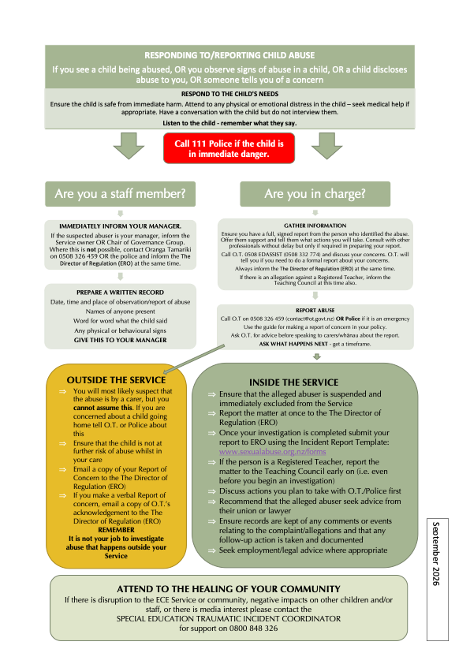

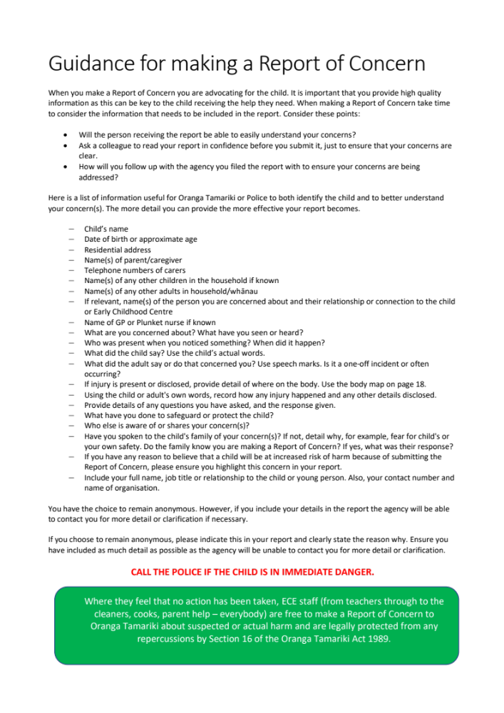(Inspired by safeguardingchildren.org.nz)

Physical signs and symptoms
Physical indicators that should raise suspicion for maltreatment include the following:
- Injury pattern inconsistent with the history provided
- Multiple injuries/multiple types of injuries
- Injuries at various stages of healing
- Poor hygiene
- Presence of pathognomonic injuries (characteristic injuries), including loop marks; forced immersion burn pattern; and classic abusive head trauma findings of subdural hematoma, retinal haemorrhage, and skeletal injuries
Bruising over bony prominences is common in childhood, but patterns of bruising that raise the concern of possible abuse include the following:
- Involvement of multiple areas of the body beyond bony prominences
- Bruising of ears, facial cheeks, buttocks, palms, soles, neck, genitals
- Bruises at many stages of healing
- Bruises in a non-ambulatory child
- Patterned markings resembling objects, grab or slap marks, bites, and loop marks
- Oral injury, lingula or labial frenula tears
Skeletal injuries in children younger than 2 years may not be obvious; therefore, a skeletal survey screening is recommended. Fractures that raise a high degree of suspicion for inflicted injury include the following:
- Any fracture in a non-ambulatory infant without clear accidental and consistent mechanism
- Metaphyseal fractures (the neck portion of a long bone)
- Multiple, bilateral, differently aged posterior rib fractures
- Multiple and complex skull fractures if only simple impact history
- Spinous process fractures (a break or crack in the back part of a vertebra)
- Scapular fractures
Burn patterns that may suggest physical maltreatment include the following:
- Patterned contact burns in clear shape of hot object (eg, fork, clothing iron, curling iron, cigarette lighter)
- Classic forced immersion burn pattern with sharp stocking-and-glove demarcation and sparing of flexed protected areas
- Splash/spill burn patterns not consistent with history or developmental level
- Cigarette burns
- Bilateral or mirror image burns
- Localized burns to genitals, buttocks, and perineum (especially at toilet-training stage)
- Evidence for excessive delay in seeking treatment, and the presence of other forms of injury
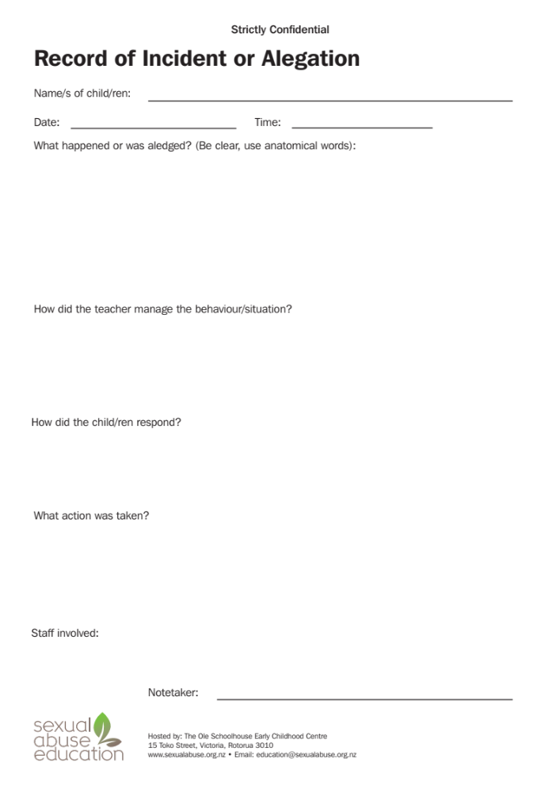

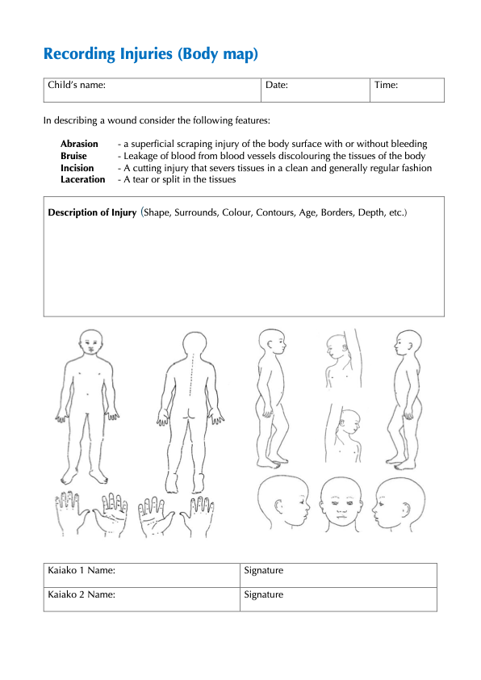
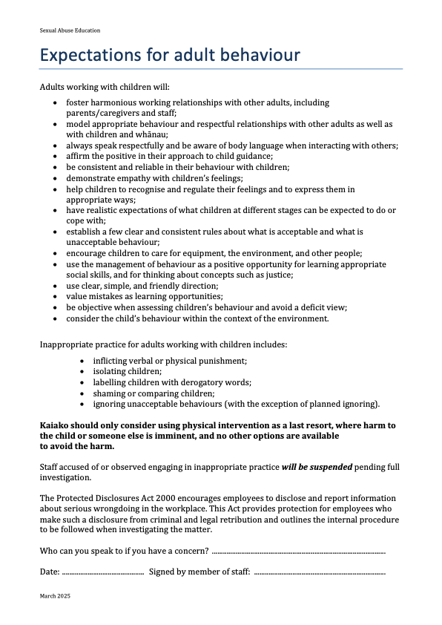

Contacts
AGENCY | PHONE NUMBER | INFORMATION
New Zealand Police | 111 | If you believe a child is in immediate danger, call NZ Police on 111.
Oranga Tamariki | 0508 EDASSIST (0508 332 774) or email edassist@ot.govt.nz  (this is the dedicated contact for schools and early learning services) | If you are worried about a child or want to discuss, report, or refer a concern, contact Oranga Tamariki.
Healthline | 0800 61 11 16 | Healthline can provide you with advice about a child who appears unwell or hurt, or has any symptoms of sickness.
Shine Helpline | 0508 74 46 33 | Shine can provide advice and support for anyone seeking information about family harm.
Crimestoppers | 0800 55 51 11 | If you have any concerns about reporting a potential case of family harm, Crimestoppers will support you to pass on key information anonymously.
Are You Ok | 0800 456 450 | Are You OK helpline will be able to provide information and advice on family violence. As well as referrals to local family violence services.
Safe to Talk | 0800 044 334 or email support@safetotalk.nz | Safe to Talk helpline will be able to provide information and advice on sexual harm. As well as referrals to local sexual harm services.
Special Education Traumatic Incident Coordinator | 0800 84 83 26 | Support if there is disruption to the ECE Service or community, negative impacts on other children and/or staff, or there is media interest.

If you’re required to notify another agency of an incident, you must notify The Director of Regulation (ERO) at the same time (HS128). This includes any notification to WorkSafe, the Teaching Council, Oranga Tamariki or health authorities etc.

